DOOR BELL

Circuit Diagram-:

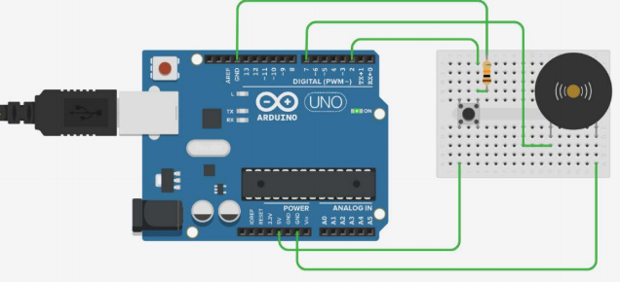

Theory and Concept used-:

1. When button is pressed buzzer beeps
2. No sound when button is not pressed

Learning Outcomes -:

1. Handling switch button.
2. How to control arduino and its coding.
3. Use of buzzer

Observation-:

1. Beeping of buzzer
2. Timed pressing of switch button

Problems and Troubleshooting-:

1. Proper connection of buzzer and switch.
2. Proper connection of wire.
3. To check loose wires.

Precautions-:

o Handle tools carefully

o Wear gloves

o Do not connect arduino till the circuit is complete

Outcomes-:

1. Beeping of buzzer when switch is pressed.
2. Used as a door bell.